GBB-F Heat Seal Tester
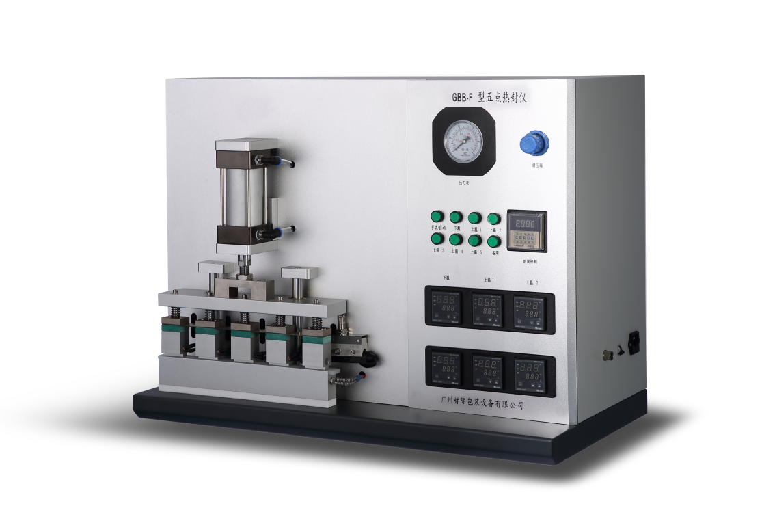
Application
GBB-F Heat Seal Tester is to test the temperature, pressure, and time for heat sealing of various film materials. It is applied to quality inspection organizations, drug control institutions, research institutes, packaging, thin film, food companies, pharmaceutical enterprises, personal care industry and so on.

Standards
QB/T 2358, ASTM F2029, YBB 00122003

Features
- Heat sealing with five points to set five different temperatures.
- Upper and lower heat seal bars have independent temperature control and can be set separately.
- Use compressed air, pneumatic drive.
- Automatic and manual modes; use foot switch for manual mode.
- Support customize size, shape and smoothness of heat seal bar.
- Support upgrade heat seal bar with anti-sticking function.
- Temperature calibration is simple.

Specifications
Item | Technical parameters
Temperature range | Room temperature~250℃
Temperature precision | ±1℃
Seal time range | 0.01s~99.99h
Pressure range | 0~1Mpa
Heat seal area | Upper bar: 35×10mm × 5 sections,  lower bar has silicone pad as buffer; (customize  available)
Heat seal method | Two ways: automatic or manual, external air cylinder
Gas source | compressed air
Power | 1300W
Power supply | AC220V 50Hz
Weight | 55 kg
Instrument size | 730mm × 400mm × 540mm

Configuration List
A、Spare parts
NO. | Name |  | Remark | Quantity
1 | Power cable |  | 3*0.75 10A 1.8 M | 1 PC
2 | Foot switch |  | FS-1 | 1 PC
3 | Allen wrench |  |  | 1 PC
4 | Cross screwdriver |  | 6-10mm | 1 PC
5 | Wooden box |  |  | 1 PC
6 | Keys |  |  | 1 PC
B、Optional parts
NO. | Name | Unit | Quantity | Remark
1 | Metrology Certificate |  |  | Optional
2 | Air compressor |  |  | Optional
C、User provide
1 | Power supply 500w 220V 10A three holes socket ground wire
2 | Air source（such as, air compressor）specification 2.5HP, 8KG pressure
3 | High-pressure air pipe（Φ8mm plastic pipe)
4 | Air filter（filter dust, filter oil, filter water)

Note: GBPI is always committed to product innovation and improved performance, so accordingly product technical specifications are subject to change without notice. GBPI reserves the right to amend and the final power of interpretation.

